Dear Parents,

Friday 25 June ● Form 4 Medieval Feast

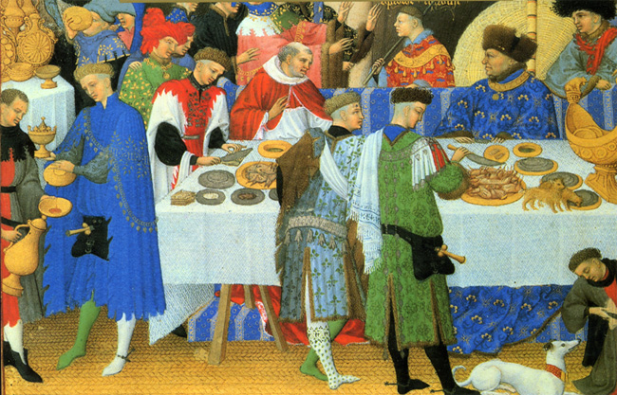

As part of their study of the Middle Ages, Form 4 will be taking part in a medieval feast. This will take place at school during part of the academic day. Pupils are encouraged to dress up for the day; dressing up ideas may be found on this page but please don’t go to any expense; a piece of material, tights and a belt should work well. They may want to come as a monk, knight, princess or peasant. They will get changed into their costumes before lunch so should come into school in their school uniform. We do lay on a magnificent feast, which includes a roast suckling pig. To cover costs £4 will be added to the end of term bill.


Thank you for your support.

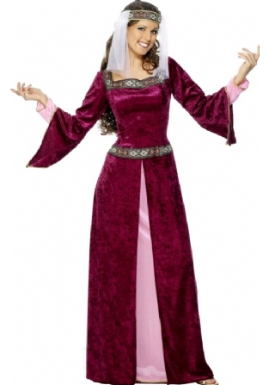
Stuart Raeburn-Ward

